Explore Weather Trends

Meets Specifications

**Analysis**

* The SQL query used to extract the data is included.
* The query runs without error and pulls the intended data.

**To Exceed Expectations** It is possible to actually get the data in a single query after you get the list of cities you can choose from. It would be could training to learn how to do this. [This](https://www.w3resource.com/sql-exercises/) site helped me a lot as a student. I would recommend attempting to query the entire data in one pass. Here is an example…  
[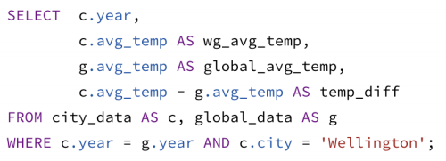](https://gyazo.com/19fa98694a03c5391a1fd6c0760ce1ab.png)

Moving averages are calculated to be used in the line chart.

* A line chart is included in the submission.
* The chart and its axes have titles, and there's a clear legend (if applicable).
* The student includes four observations about their provided data visualization.
* The four observations are accurate.